Full name: ……………………………….
EXERCISE No.2
I/ Look at the pictures and letters, and then write the words.
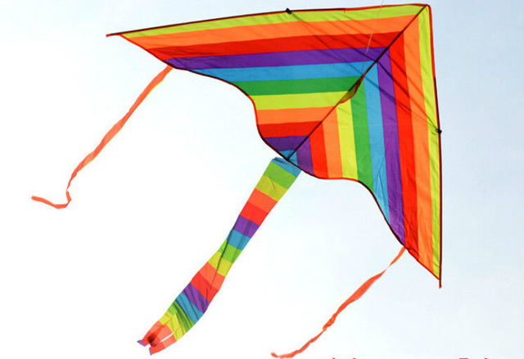 ----
i t
k e
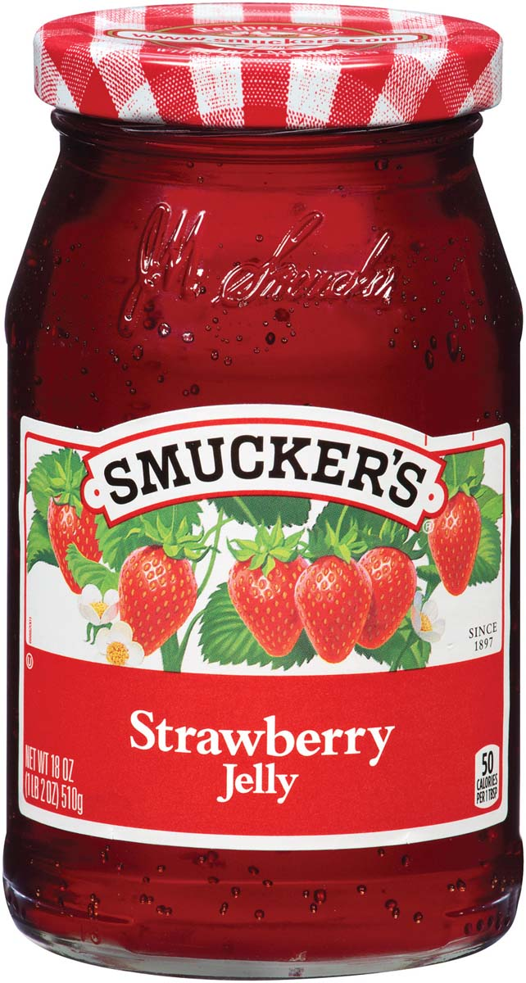 -----
w s e
a s e
l e
j y l
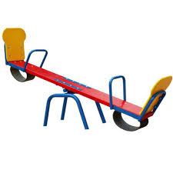 ------
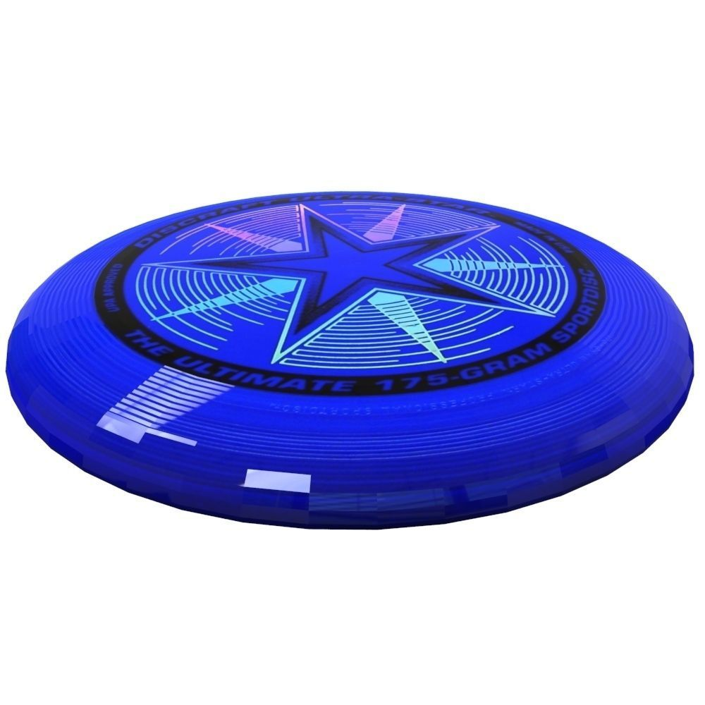 -------
e r s
b f i e
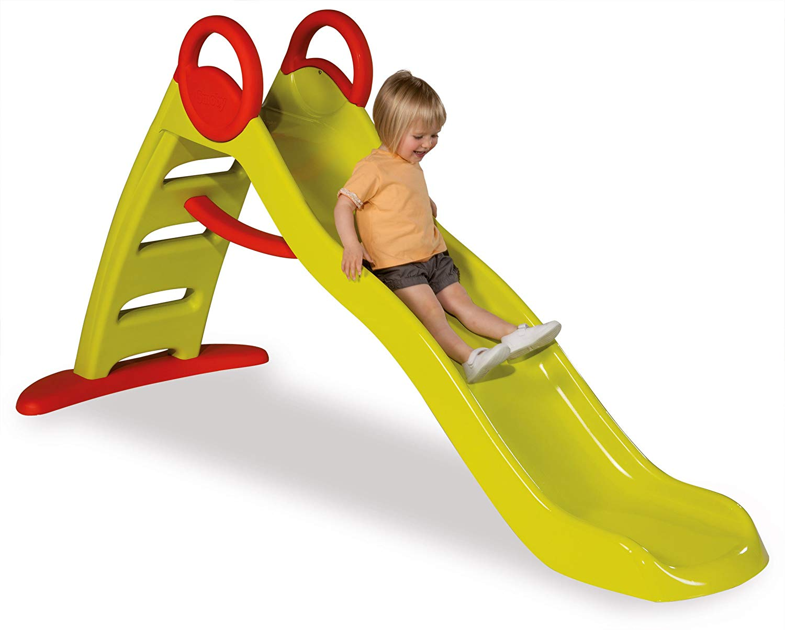 -----
l e s
i d
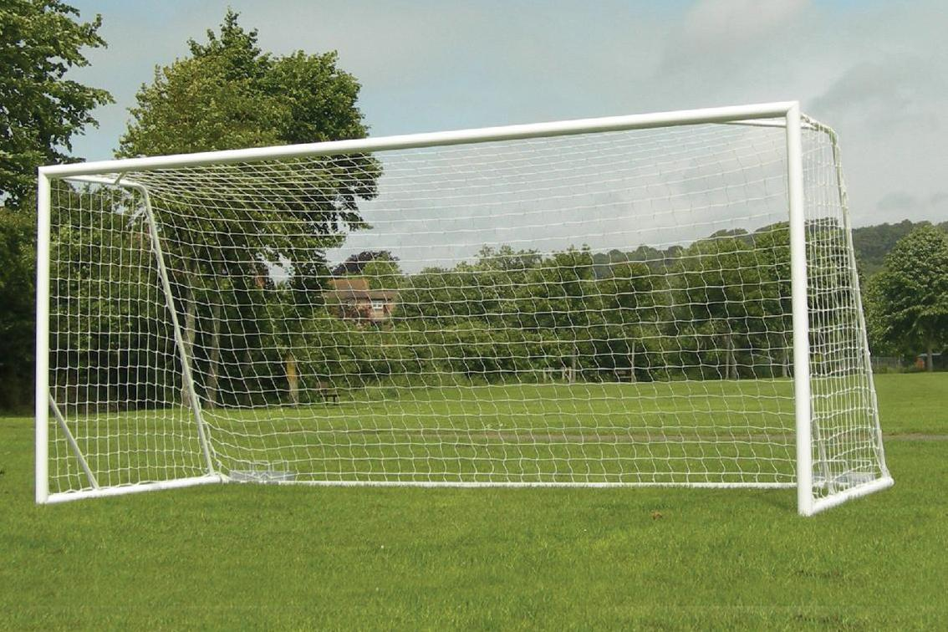 ----
a g
o l

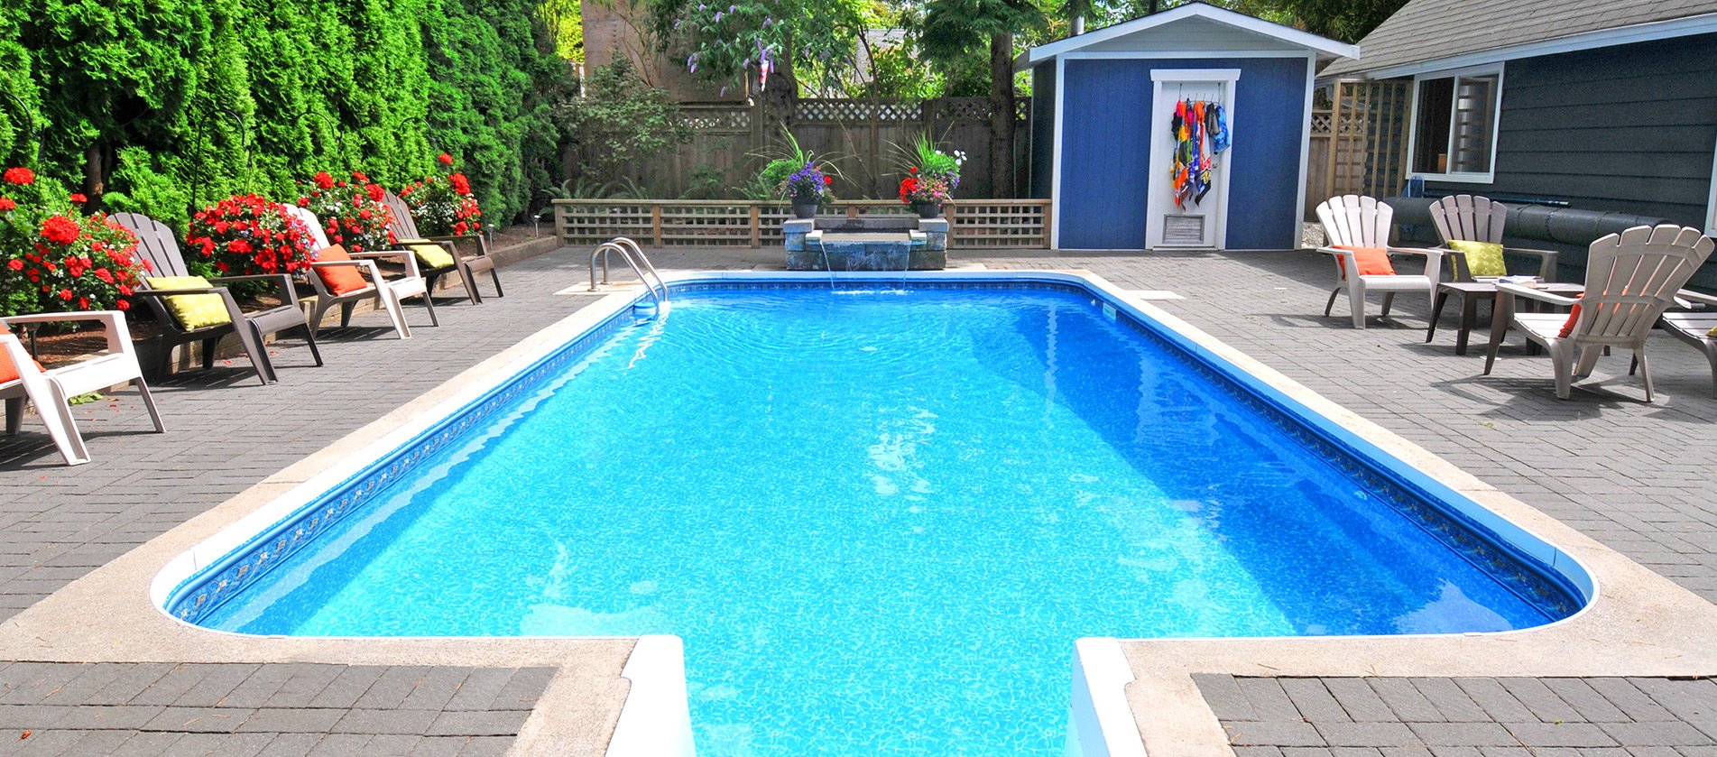 ----
o l
p o
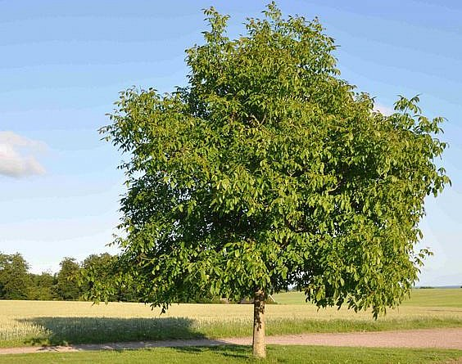 ----
r e
e t
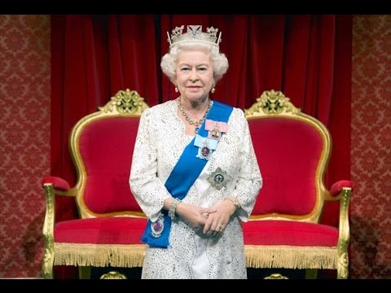 -----
e n
u e q
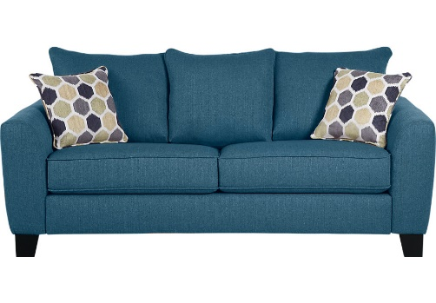 ----
f a
o s
II/ Use “a” or “an”
1/ ................... ant
2/ ................... doll
3/ ................... dog
4/ ................... egg
5/ ................... sofa
6/ ................... arm
7/ ................... fig
8/ ................... orange
9/ ................... pencil
10/ ................... ice-cream
III/ Rearrange these words
1/ pink / it / is /. …………………………………………...
2/ it / what / is / color / ? …………………………………………...
3/ is / her / what / name / ? …………………………………………...
4/ I / doctor / a / am / . …………………………………………...
5/ his / is / ? / that / book …………………………………………...
6/ name / his / . / Billy / is …………………………………………...
7/ ball / in / goal / the / . / is / the …………………………………………...
8/ dog / the / is / tree / under / the …………………………………………...
9/ kite / on / slide / the / . / is / the …………………………………………...
10/ is / on / it / the / . / seesaw …………………………………………...
IV/ Missing letters
1/ umbr…ll…
2/ …iger
3/ Q…ee…
4/ r…bbit
5/ ic…-cr…am
6/ st…dent
7/ t…acher
8/ far…er
9/ p…lice …fficer
10/ f…refighter

Good luck!

